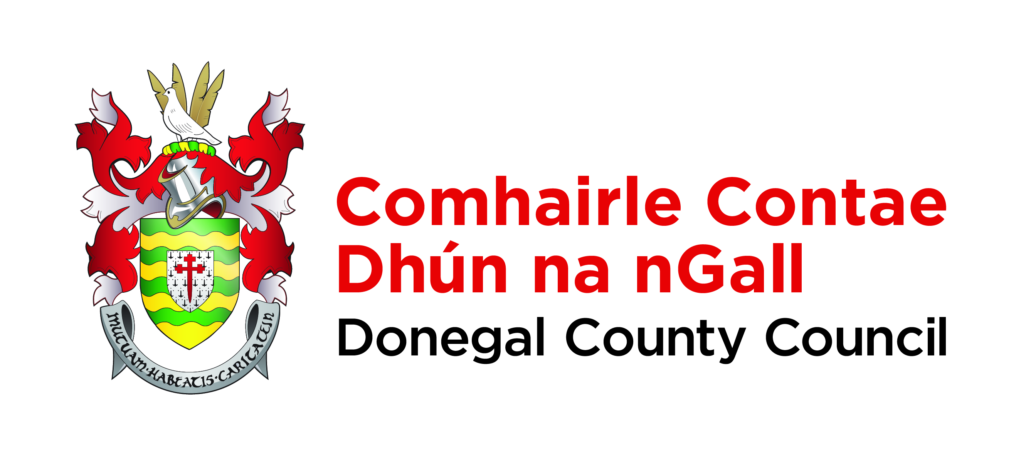

Road Traffic Act, 1994 – Section 36

NOTICE OF PROPOSED MAKING OF BYE-LAWS FOR THE CONTROL AND REGULATION OF PARKING OF VEHICLES IN PARKING PLACES ON PUBLIC ROADS IN THE TOWN OF BALLYSHANNON

Donegal County Council (Parking Places) (Amendment) Bye Laws 2019

TAKE NOTICE that:

- Donegal County Council proposes to make the above amending Bye-Laws under Section 36 of the Road Traffic Act, 1994 to control and regulate the parking of vehicles on Public Roads in the town of Ballyshannon. The purpose of the Bye Laws is to remove the existing on street paid parking requirements in the town of Ballyshannon.

- A copy of the draft Bye-Laws will be available for Public inspection at Donegal Public Services Centre, Drumlonagher, Donegal Town during the hours of 9.00am and 4.30pm each weekday Monday to Friday excluding public holidays for the period of one (1) month from the publication of this notice.

- Representations in relation to the draft Bye-Laws may be made in writing to the Council not later than 12.00 noon on the 14th day of January 2019, which will then be considered by the Council. All such representations should be addressed to Donegal County Council, Donegal Public Services Centre, Drumlonagher, Donegal Town, Co. Donegal.

- A copy of the said draft Bye-Laws may be obtained during the times and from the office mentioned in paragraph 2 above without charge.

Dated this 16th day of November 2018

Signed: John G. McLaughlin
Director of Services Roads and Transportation.

