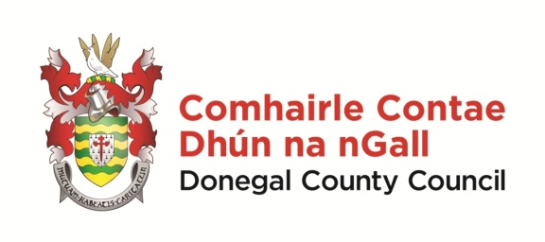 | Scéim Scoláireachta 2024  Gaeltacht Scholarship Scheme 2024  Foirm Iarratais/Application Form

NÓTA: Please take the time to complete this application form clearly and legibly.
Details of successful candidates will be forwarded to the relevant colleges.

Applicant Details:

Ainm/Name: _____________________ Sloinne/Surname: ___________________________

Seoladh/Address: _________________________________________________________________
__________________________________________________________________________________

Aois/Age: ______________ Uimhir Theileafóin/Phone no: ________________________

Ríomhphost /Email: ______________________________________________________________

Deimhnigh/confirm email: __________________________________________________________

Name of school you currently attend:

Which Gaeltacht College do you wish to apply for?

Have you secured a place with a Gaeltacht College for 2024? If so, give details –

__________________________________________________________________________________
If we are unable to offer you a place on the college of your choice, would you like to be considered for other colleges? Yes ___ No ___

Do you consent to a photo of your child being taken for the purposes of promoting the scheme?
Yes _______ No ________

Síniú an Tuismitheora/Chaomhnóra:
Parent or Guardian Signature:

Name of Parent or Guardian in BLOCK CAPITALS: _________________________________________

Dáta/Date

Seol d’iarratas chuig/please forward application to –

sceimscol@donegalcoco.ie

nó chuig - Róise Ní Laifeartaigh, Oifigeach Gaeilge Pobail, Rannóg na Gaeilge,
Comhairle Contae Dhún na nGall, Ionad Seirbhisí Poiblí, Leitir Ceanainn, Contae Dhún na nGall.

Application Forms to be received on or before -Thursday, 22 Feabhra 2024

Cuirfear fios ar na buaiteoirí/successful applicants will be notified/i mí an Mhárta/in March 2024

