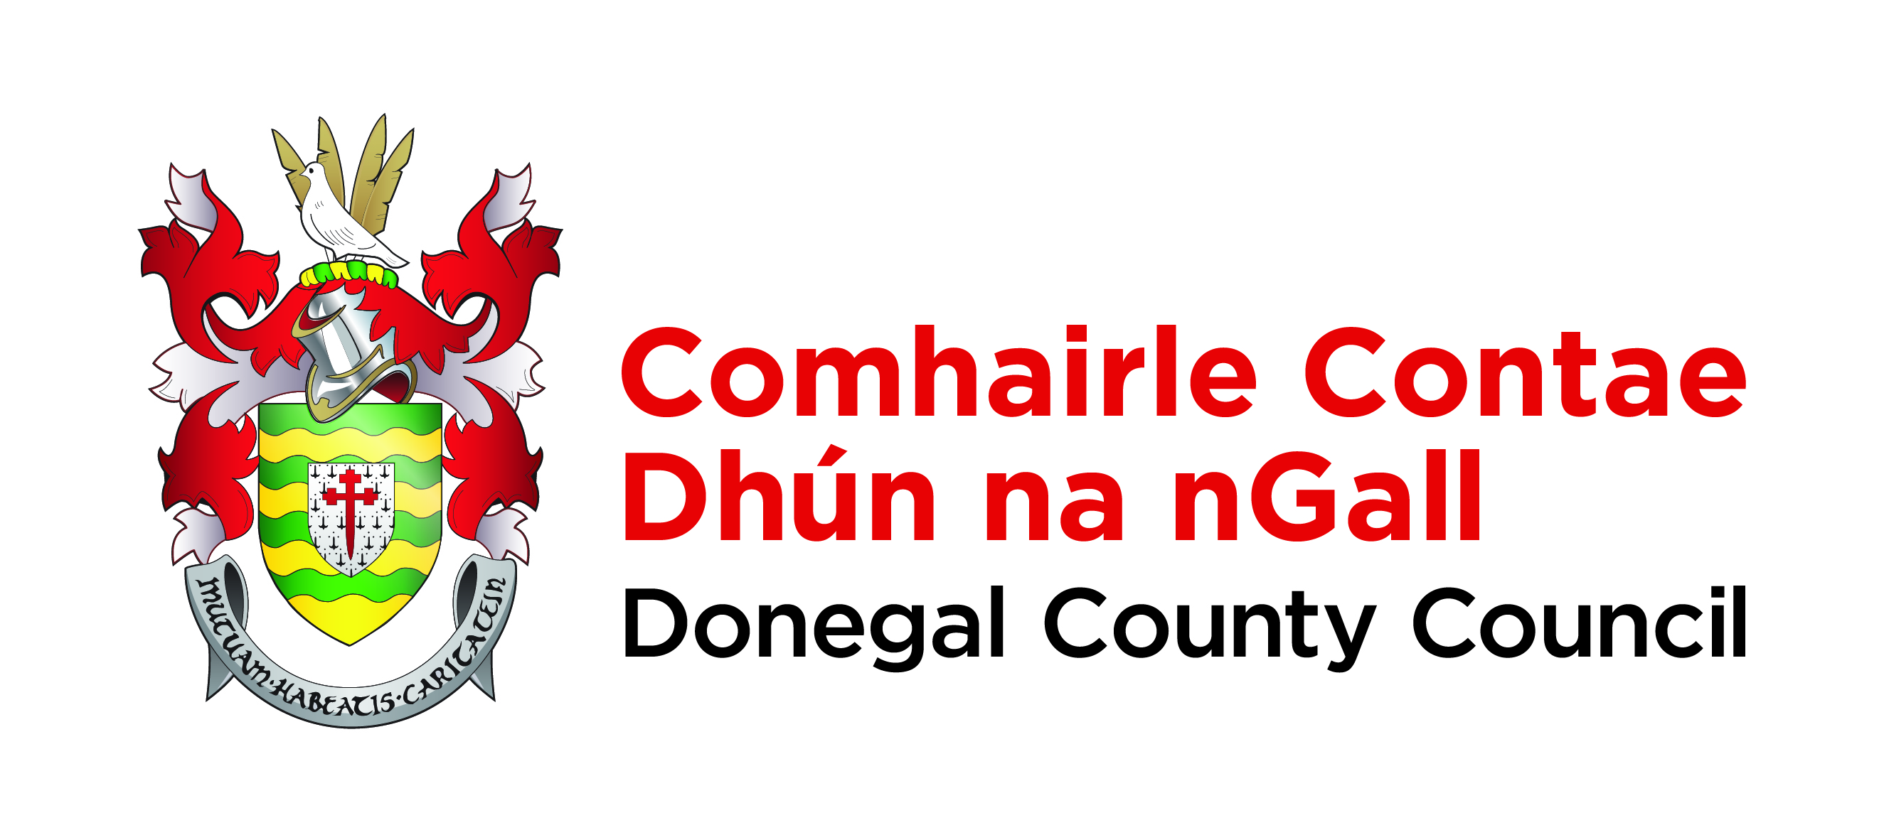

Donegal’s Decarbonising Journey

NAME OF COMMUNITY/GROUP:

Contact Names for Correspondence:

Position in Group/Organisation:

E-mail Addresses for Correspondence:

About your community/group:
Name
Population
Size – km sq
Townlands included (please provide outline google map of area)
Number of schools in the area
  - Primary
  - Secondary
  - Third level
Significant/High Energy Users in Zone
Main employment in area

To meet the ambitious targets of reducing emissions by over 50% by 2030 will require a whole of community approach. Donegal County Council is interested in learning about the climate action activities in your community.
- Community Activity (since 2015)
a) Outline previous successful community projects
- Community awards eg. Pride of Place, other community awards.
- Community assets eg. Community centre, playground, community walks etc.
- Participation in previous Donegal County Council environmental and/or biodiversity campaigns eg. Cleaner communities, Community Action Fund, LAWPro.
- Registered with Donegal Public Participation Network (PPN)?
b) Existing relevant environmental community plans
- Are you Sustainable Energy Communities (SEC), Renewable Energy Communities (REC), Energy Cooperatives or the Renewable Electrical Support Scheme (RESS).
- Do you have a SEC Energy Master plan or other renewable energy plan.
- Do you have a Biodiversity Plan?
- Other relevant plans eg. Flood alleviation plan, climate action plan, carbon sequestration.
c) Previous climate action projects
Provide details on previous climate action projects. Highlight if the project was a success and give metrics to prove success. If project was not as successful as envisaged please provide details as to why.
Examples of projects to include:
- Better Energy Community Projects
- Community Energy
- Carbon sequestration
- Climate adaptation measures eg. Flood alleviation/prevention
- Smarter Travel projects
- Biodiversity
- Other

Does your community have (please expand where relevant)?
Public Transport
Fibre broadband connection
Wastewater Treatment Plant connection or Septic Tanks
Green and blue Spaces i.e. rivers, lakes, parks etc.
Agriculture (identify type i.e. Beef, dairy, sheep, tillage, vegetable, other)
Forestry (i.e. Amenity forests, native woodlands, farm forests, upland and peatland forests)
Wetlands/bogs
Cycle/walk ways
EV charging points (no.)
Remote working hubs
Public buildings in Zone
Protected Areas eg. SACs, SPAs
Local Area Plans
Brownfield and former commercial / industrial sites

