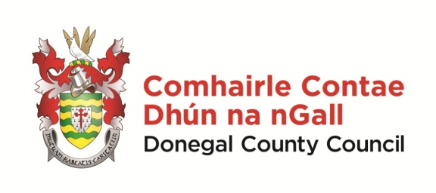 | Scéim Scoláireachta 2022  Gaeltacht Scholarship Scheme 2022  Foirm Iarratais/Application Form
NÓTA: Líon isteach an fhoirm iarratais seo go soiléir agus go cúramach, le do thoil
Please take the time to complete this application form clearly and legibly.
Details of successful candidates will be forwarded to the relevant colleges.

Iarrathóir/Applicant Details:

Ainm/Name: _____________________ Sloinne/Surname: _____________________________

Seoladh/Address: __________________________________________________________________
__________________________________________________________________________________

Dáta Breithe/DOB: ______________ Uimhir Theileafóin/Phone no: ______________________

Ríomhphost /Email: ________________________________________________________________

Deimhnigh/confirm email: ___________________________________________________________

Ainm na scoile ar a bhfuil tú ag freastal faoi láthair/Name of school you currently attend:

An bhfuair tú scoláireacht ón Chomhairle seo roimhe? Yes _____ No ______
Have you previously received a scholarship from this Council?

Cén Coláiste Gaeltachta a ba mhaith leat freastal air? Which Gaeltacht College would you like to attend?

Mura bhfuil muid in ann áit a thairiscint duit don Choláiste a roghnaigh tú thuas, ar mhaith leat a bheith san áireamh do Choláistí ar bith eile? Má chuireann tú tic le ‘níor mhaith’, ní bheidh muid in ann aon rogha eile a thairiscint duit.
If we are unable to offer you a place on the college of your choice, would you like to be considered for other colleges? If you tick ‘no’, no alternative offers will be made, if your first choice is not available.
Ba mhaith/Yes ___ Níor mhaith/No ___

Do you consent to a photo of your child being taken for the purposes of promoting the scheme?
Yes _____ No ________

Síniú an Tuismitheora/Chaomhnóra/
Parent or Guardian Signature:
Ainm an Tuismitheora/Chaomhnóra/
Name of Parent or Guardian in BLOCK CAPITALS: _________________________________________

Dáta/Date

Seol d’iarratas chuig/please forward application to –

sceimscol@donegalcoco.ie

nó chuig - Róise Ní Laifeartaigh, Oifigeach Gaeilge Pobail, Rannóg na Gaeilge, Comhairle Contae
Dhún na nGall, Ionad Seirbhisí Poiblí, Leitir Ceanainn, Contae Dhún na nGall.

Foirmeacha Iarratais le bheith istigh ar nó roimh/applications to be received on or before –Dé hAoine / Friday 11 Márta/March
Cuirfear fios ar na buaiteoirí/successful applicants will be notified/i mí an Mhárta/in March 2022

