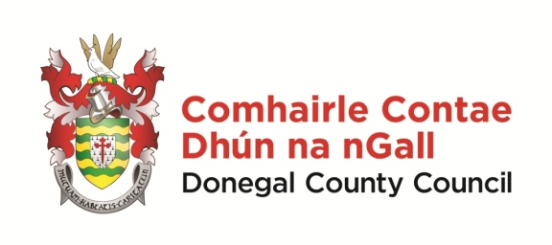 | Scéim Scoláireachta 2025  Gaeltacht Scholarship Scheme 2025  Foirm Iarratais/Application Form

NÓTA: Please take the time to complete this application form clearly and legibly.
Details of successful candidates will be forwarded to Coláiste Ghaoth Dobhair.
Applicants must be between 13 – 16yrs

Applicant Details:

Ainm/Name: _____________________ Sloinne/Surname: ___________________________

Seoladh/Address: _________________________________________________________________
__________________________________________________________________________________

Aois/Age (yrs): ______________ Dáta Breithe/DOB: _____________________

Uimhir Theileafóin/Phone no: ________________________

Ríomhphost /Email: ______________________________________________________________

Deimhnigh/Confirm email: __________________________________________________________

Name of school you currently attend:

Scholarships are being offered for Coláiste Ghaoth Dobhair only in 2025.
Do you wish to be included in the Scéim Scoláireachta on this understanding?

Yes: ______ No: ______

Do you consent to a photo of your child being taken for the purposes of promoting the scheme?
Yes _______ No ________

Síniú an Tuismitheora/Chaomhnóra:
Parent or Guardian Signature:

Name of Parent or Guardian in BLOCK CAPITALS: _________________________________________

Dáta/Date

Seol d’iarratas chuig/please forward application to –

sceimscol@donegalcoco.ie

nó chuig - Róise Ní Laifeartaigh, Oifigeach Gaeilge Pobail, Rannóg na Gaeilge,
Comhairle Contae Dhún na nGall, Ionad Seirbhísí Poiblí, Leitir Ceanainn, Contae Dhún na nGall.

Application Forms to be received on or before – Dé Luain/Mon, 14/4/2025
Cuirfear fios ar na buaiteoirí roimh dheireadh mhí Aibreáin 2025 /Successful applicants will be notified by end of April 2025

