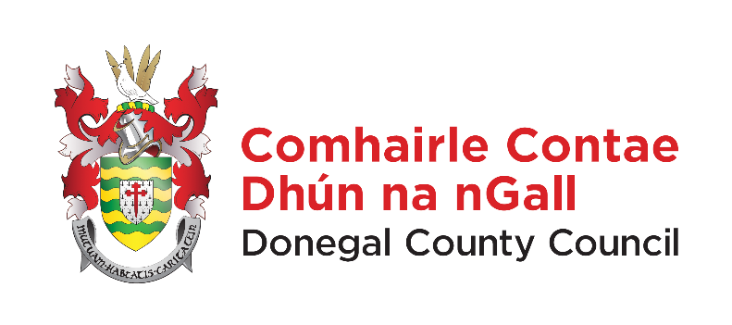

Annual Report of Donegal County Council required under Protected Disclosure Act 2014

Section 22 of the Protected Disclosure Act 2014 requires the publication of a report each year relating to the number of protected disclosures made in the preceding year and also for the publication of information with regard to any actions taken in response to protected disclosures made.

Donegal County Council confirms that 1 no. protected disclosure was received in the reporting period up to 31st December, 2024.

