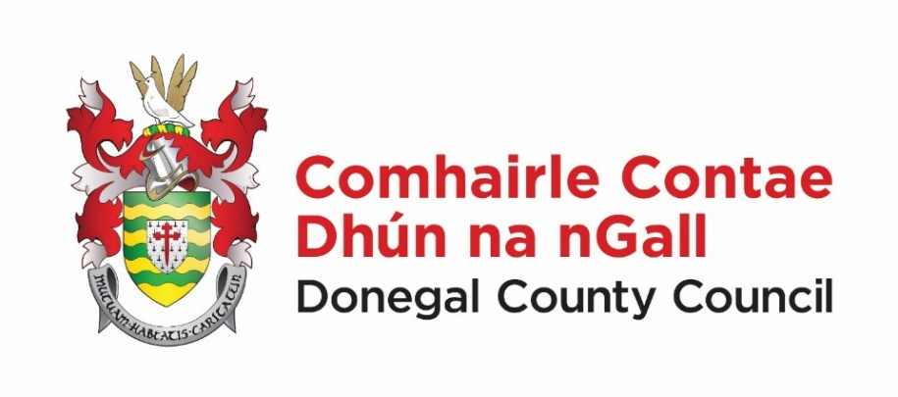

**Domestic Waste Water Treatment Systems Grant**

**Under the**

**National Inspection Plan**

**Claim Payment Form DWWTS NIP (a)**

Central Laboratory

Donegal County Council

Railway Road

Stranorlar

Lifford PO

Co Donegal

Eircode F93X273

Phone No.: 074 9153900

Email Address: info@donegalcoco.ie Version (April 2025)

|  |
| --- |
| GRANT PAYMENT CLAIM FORM  Works for the remediation, repair, upgrade or replacement of a Domestic Waste Water Treatment System (DWWTS), related to an inspection under the National Inspection Plan.   * Please read the information notes before completing the claim form. * All questions on the form must be answered and where specified, supporting documents must be provided. Incomplete forms, or those which are not accompanied by the appropriate documents, will not be processed. * Work must NOT have started before the local authority or its representative’s initial visit. If work started before that date, the claim will not be considered. * The grant scheme is administered by local authorities. Any enquiries should be addressed to the local authority’s Rural Water Liaison Officer. * All forms to be used can be obtained from the local authority, who will provide assistance with completing them, if required. * In respect of an applicant receiving grants, subsidies or similar type payments from a Government Department or Public Authority that have a total value of more than €10,000 during the year, you will need an e-Tax Clearance certificate. * The local authority reserves the right to make any necessary enquiries to verify information or for clarification of supporting documents provided with a grant application. An application that includes false or misleading information or documents will not be approved for a grant. |

|  |  |
| --- | --- |
| 1. **Details of the Applicant** | |
| Name of applicant (in block capitals): |  |
| Address (location of DWWTS):  EIRCODE (required): |  |
| Telephone no: |  |
| E-Tax clearance printout | Yes 🞏󠄀 No 🞏󠄀 |
| E-mail address: |  |
| In the last 12 mths, have you received a grant from any public body?  If yes, please provide details:   * amount: * date paid: | Yes 🞏󠄀 No 󠄀🞏  € |
| 1. **Details of the DWWTS** | |
| Date inspection carried out: |  |
| Advisory Notice reference number: |  |
| Date of local authority Notice of Compliance: |  |
| 1. **General description and cost of works carried out** (Itemised receipt(s) must be provided when the works are completed): | |
|  | |
| 1. **Previous Payments** | |

|  |  |
| --- | --- |
| Was any grant paid in respect of this DWWTS in the last 7 years?  If yes, please provide details:  amount:  date paid: | Yes 🞏󠄀 No 󠄀🞏  € |

|  |  |
| --- | --- |
| 1. **Details of Contractor(s)** (e-Tax Clearance printout for each contractor must be provided) | |
| Contractor 1 | Contractor 2 (if applicable) |
| Contractor name: | Contractor name: |
| Contractor address:  EIRCODE: | Contractor address:  EIRCODE: |
| 1. **Declaration** | |
| I declare that the information provided by me on this grant payment claim form is correct and I understand that the provision of any false or misleading information or invalid supporting documents may result in this claim being cancelled.  **Signature of claimant:**  **Date:** | |