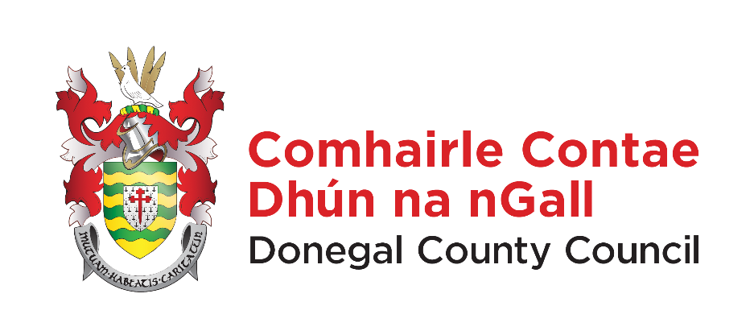

COMHAIRLE CHONTAE DHUN NA nGALL
DONEGAL COUNTY COUNCIL
COUNTY HOUSE, LIFFORD, CO. DONEGAL F93 Y622

NOTICE IS HEREBY GIVEN in accordance with Section 3 of The Local Government Rates (Financial Procedures) Regulations 2023 that the Annual Rateable Valuation (ARV) for all rateable properties within the rating authority of Donegal County Council for the financial year commencing on 1st of January 2026 and ending on 31st of December 2026 is €0.232.

- Commercial Rates are now due from 1st January annually and are payable as a single charge. However, the Council will continue to accept monthly direct debit payments, if requested.
- Section 12 of the Local Government Rates and Other Matters Act 2019 provides for the imposition of interest on overdue rates. As per Section 12 unpaid rates “shall carry interest from the first day of January in the year following the local financial year to which the rates relate until payment”.
- A daily interest rate of 0.0219 or 8% per annum will apply from January 1st 2026 to rates unpaid from 2025.

Dated this 5th January 2026

Signed: - John G. Mc Laughlin
Chief Executive
Donegal County Council

